**Day 448**

**https://people.eecs.ku.edu/~d590i996/Day448/index.html**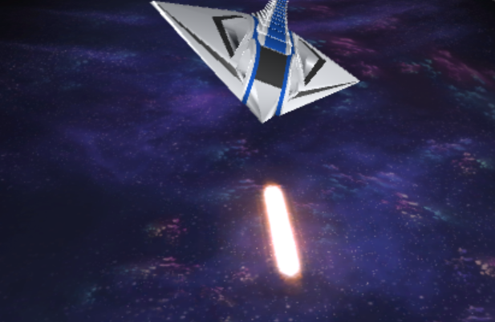

Cold, empty space … Communications cut off … Rations running low …  
  
It is day 448, and you are flying through space to get to the nearest known civilized world. Being on your last leg of resources, you thought things couldn’t get any worse – then your radar began to alert you … about an oncoming asteroid field.

In Day 448, you are the pilot of a spaceship hurtling through an asteroid field, collecting rare Infinity Shards and trying to stay alive.

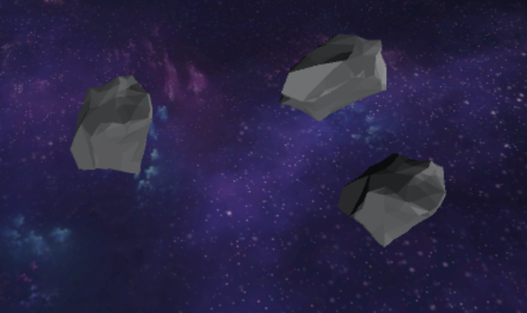

Throughout the game,

the focus is to avoid getting

struck by the asteroids

hurtling towards you at

varying speeds.



To avoid the asteroids, the player may maneuver the ship vertically by pressing either the Up, Down, W or S keys

 X

The ship is equipped with a laser capable of destroying asteroids which can be triggered by pressing space or the left mouse button.

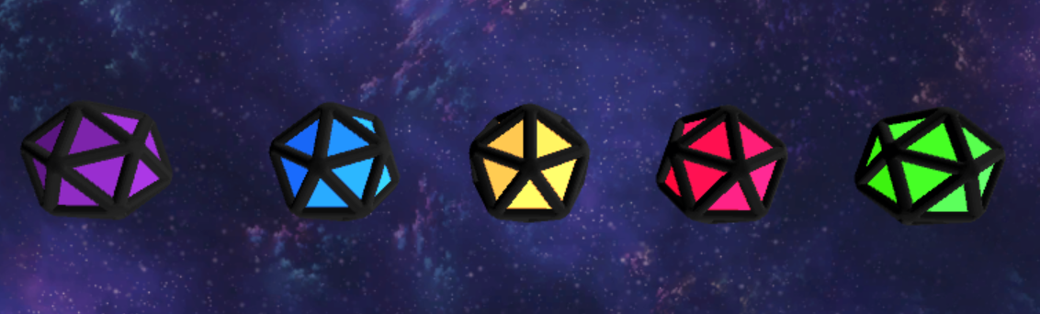Throughout the asteroid field, astral forces have imbued certain space particles with special properties. These particles, called Infinity Shards, alter reality and give the ship highly advanced upgrades when picked up.

|  |  |  |  |  |
| --- | --- | --- | --- | --- |
| Astral Bomb | Upgraded  Laser | Astro Shield | Dimensional  Shrink | Bend  Time |
|  |  |  |  |  |
| Releases a shockwave which destroys all nearby asteroids. | Upgrades the laser to ignore the laws of thermodynamics,  causing it to fire continuously without overheating. | Creates a shield around the player, destroying any asteroids that come in contact with it. | Shrinks the ship to half size and doubles the speed to aid with maneuvera-bility | Warps reality and slows down time. |